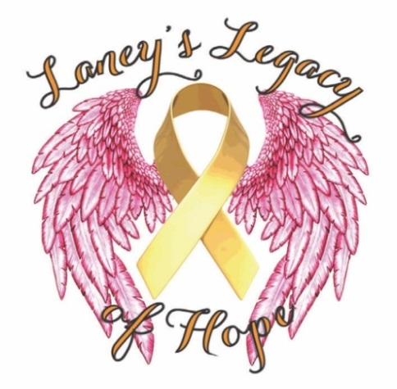
Sponsorship Agreement Form
Laney’s Legacy of Hope’s
5th Annual Fashionista 5K

Form and Logo Deadline:
April 10th 2018
Submit to: Laney’s Legacy of Hope
P.O. Box 5861
Wyomissing, PA 19610
nplank@laneyslegacyofhope.org
610-763-1407

Checks made payable to: Laney’s Legacy of Hope
Credit Card payments & form also available via LaneyLegacyofHope.org

Please submit completed agreement, company logo with payment (company cards, brochures coupons or additional marketing materials to be added to swag bag *optional) by April 10th 2018. We cannot guarantee benefits for any forms submitted late.

Please check one:
Platinum Sponsor ($1,000 and up) Gold Sponsor ($500-$999)
Silver Sponsor ($250-$499)

Company Name (as you would like it to appear): ____________________________________________
Contact Name: ____
Address: __ City/State/Zip _____________
Phone Number: Email*:
*Required for follow through of benefits only. Not for other use.
Platinum Sponsor $1,000 or greater (**limited number at this level…hurry!**)
- Donation made for $1000 or more
- Company name & logo exclusively featured at the starting line (signage provided by Sponsor)
- Company name exclusively featured on the Laney’s Legacy of Hope website till next calendar race
- Company name & logo placed featured on the back of the race t-shirt
- Company name on the flyer in our “Swag Bags”
- 4 Free runners
- Sponsor may add company brochures, business cards, or coupons to swag bag

Gold Sponsor $500- $999
- Donations made for $500-$999
- Company name & logo featured on the back of the race t-shirt
- Company name on the flyer in our “Swag Bags”
- 2 Free runners
- Sponsor may add company brochures, business cards, or coupons to swag bag

Silver Sponsor $250- $499
- Donation made for $250-$499
- Company name on the flyer in our “Swag Bags”
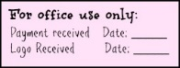
- Sponsor may add company brochures, business cards, or coupons to swag bag

